30

MONEY GROWTH AND INFLATION

WHAT’S NEW IN THE SEVENTH EDITION:

There are no major changes to this chapter.

LEARNING OBJECTIVES:

By the end of this chapter, students should understand:

➢ why inflation results from rapid growth in the money supply.

➢ the meaning of the classical dichotomy and monetary neutrality.

➢ why some countries print so much money that they experience hyperinflation.

➢ how the nominal interest rate responds to the inflation rate.

➢ the various costs that inflation imposes on society.

CONTEXT AND PURPOSE:

Chapter 17 is the second chapter in a two-chapter sequence dealing with money and prices in the long run. Chapter 16 explained what money is and how the Federal Reserve controls the quantity of money. Chapter 17 establishes the relationship between the rate of growth of money and the inflation rate.
The purpose of this chapter is to acquaint students with the causes and costs of inflation. Students will find that, in the long run, there is a strong relationship between the growth rate of money and inflation. Students will also find that there are numerous costs to the economy from high inflation, but that there is not a consensus on the importance of these costs when inflation is moderate.

KEY POINTS:

• The overall level of prices in an economy adjusts to bring money supply and money demand into balance. When the central bank increases the supply of money, it causes the price level to rise. Persistent growth in the quantity of money supplied leads to continuing inflation.

• The principle of monetary neutrality asserts that changes in the quantity of money influence nominal variables but not real variables. Most economists believe that monetary neutrality approximately describes the behavior of the economy in the long run.

• A government can pay for some of its spending simply by printing money. When countries rely heavily on this “inflation tax,” the result is hyperinflation.

• One application of the principle of monetary neutrality is the Fisher effect. According to the Fisher effect, when the inflation rate rises, the nominal interest rate rises by the same amount, so that the real interest rate remains the same.

• Many people think that inflation makes them poorer because it raises the cost of what they buy. This view is a fallacy, however, because inflation also raises nominal incomes.

• Economists have identified six costs of inflation: shoeleather costs associated with reduced money holdings, menu costs associated with more frequent adjustment of prices, increased variability of relative prices, unintended changes in tax liabilities due to nonindexation of the tax code, confusion and inconvenience resulting from a changing unit of account, and arbitrary redistributions of wealth between debtors and creditors. Many of these costs are large during hyperinflation, but the size of these costs for moderate inflation is less clear.

CHAPTER OUTLINE:

I. The inflation rate is measured as the percentage change in the Consumer Price Index, the GDP deflator, or some other index of the overall price level.

A. Over the past 80 years, prices have risen on average 3.6% per year in the United States.

1. There has been substantial variation in the rate of price changes over time.

2. From 2002 to 2012, prices rose at an average rate of 2.5% per year, while prices rose by 7.8% per year during the 1970s.

B. International data shows an even broader range of inflation experiences. In 2012, inflation was 0.1% in Japan, 5.1% in Russia, 9.3% in India, and 21.1% in Venezuela.

II. The Classical Theory of Inflation
Start off the chapter by differentiating between a “once-and-for-all” increase in the average level of prices and a continuous increase in the price level. Also make sure that students realize that inflation means that the average level of prices in the economy is rising rather than the prices of all goods.



It is instructive to review the inflation history of the United States. While your students are likely fully aware of inflation, they may not realize that, prior to World War II, the United States experienced several periods of deflation. Also point out to the students that the rate of inflation has varied significantly since World War II.

A. The Level of Prices and the Value of Money

1. When the price level rises, people have to pay more for the goods and services they buy.

2. A rise in the price level also means that the value of money is now lower because each dollar now buys a smaller quantity of goods and services.

3. If P is the price level, then the quantity of goods and services that can be purchased with $1 is equal to 1/P.

4. Suppose you live in a country with one good (ice cream cones).

a. When the price of an ice cream cone is $2, the value of a dollar is 1/2 cone.

b. When the price of an ice cream cone rises to $3, the value of a dollar is 1/3 cone.

B. Money Supply, Money Demand, and Monetary Equilibrium

1. The value of money is determined by the supply and demand for money.

2. For the most part, the supply of money is determined by the Fed.

3. The demand for money reflects how much wealth people want to hold in liquid form.

a. One variable that is very important in determining the demand for money is the price level.

b. The higher prices are, the more money that is needed to perform transactions.

c. Thus, a higher price level (and a lower value of money) leads to a higher quantity of money demanded.

4. In the long run, money supply and money demand are brought into equilibrium by the overall level of prices.

a. If the price level is above the equilibrium level, people will want to hold more money than is available and prices will have to decline.

b. If the price level is below equilibrium, people will want to hold less money than that available and the price level will rise.

Figure 1

5. We can show the supply and demand for money using a graph.

a. The horizontal axis shows the quantity of money.

b. The left-hand vertical axis is the value of money, measured by 1/P.

c. The right-hand vertical axis is the price level (P ). Note that it is inverted—a high value of money means a low price level and vice versa.

d. The supply curve is vertical because the Fed has fixed the quantity of money available.

e. The demand curve for money is downward sloping. When the value of money is low, people demand a larger quantity of it to buy goods and services.

f. At the equilibrium, the quantity of money demanded is equal to the quantity of money supplied.

C. The Effects of a Monetary Injection

1. Assume that the economy is currently in equilibrium and the Fed suddenly increases the supply of money.

2. The supply of money shifts to the right.

Figure 2

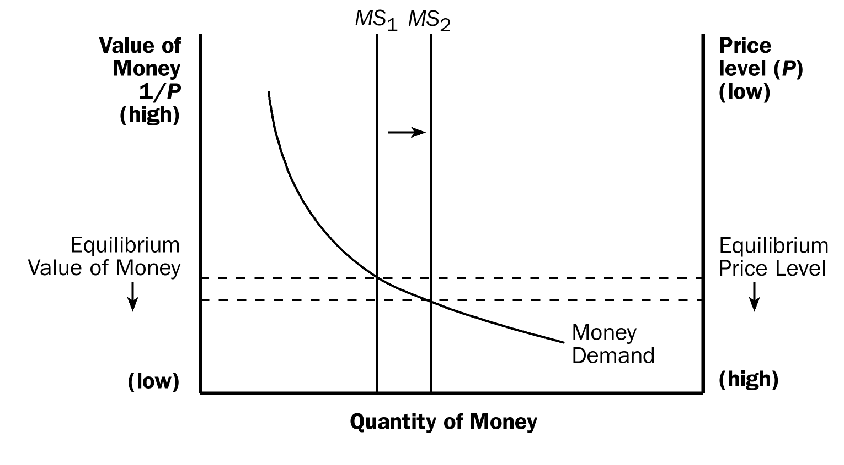
3. The equilibrium value of money falls and the price level rises.

4. When an increase in the money supply makes dollars more plentiful, the result is an increase in the price level that makes each dollar less valuable.

5. Definition of quantity theory of money: a theory asserting that the quantity of money available determines the price level and that the growth rate in the quantity of money available determines the inflation rate.

D. A Brief Look at the Adjustment Process

1. The immediate effect of an increase in the money supply is to create an excess supply of money.

2. People try to get rid of this excess supply in a variety of ways.

a. They may buy goods and services with the excess funds.

b. They may use these excess funds to make loans to others by buying bonds or depositing the money in a bank account. These loans will then be used by others to buy goods and services.

c. In either case, the increase in the money supply leads to an increase in the demand for goods and services.

d. Because the supply of goods and services has not changed, the result of an increase in the demand for goods and services will be higher prices.

E. The Classical Dichotomy and Monetary Neutrality

1. In the 18th century, David Hume and other economists wrote about the relationship between monetary changes and important macroeconomic variables such as production, employment, real wages, and real interest rates.

2. They suggested that economic variables should be divided into two groups: nominal variables and real variables.

a. Definition of nominal variables: variables measured in monetary units.

b. Definition of real variables: variables measured in physical units.

3. Definition of classical dichotomy: the theoretical separation of nominal and real variables.

4. Prices in the economy are nominal (because they are quoted in units of money), but relative prices are real (because they are not measured in money terms).

5. Classical analysis suggested that different forces influence real and nominal variables.

a. Changes in the money supply affect nominal variables but not real variables.

b. Definition of monetary neutrality: the proposition that changes in the money supply do not affect real variables.
Mankiw’s analogy of changing the size of a yard from 36 inches to 18 inches is a useful way to explain the confusion that a change in a unit of measurement (or a unit of account) can cause.

F. Velocity and the Quantity Equation

1. Definition of velocity of money: the rate at which money changes hands.

2. To calculate velocity, we divide nominal GDP by the quantity of money.

3. If P is the price level (the GDP deflator), Y is real GDP, and M is the quantity of money:
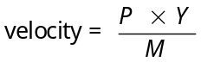

4. Rearranging, we get the quantity equation:
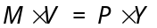

ALTERNATIVE CLASSROOM EXAMPLE:

Suppose that:
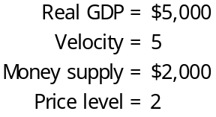

We can show that:
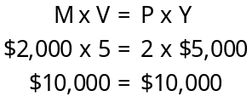

5. Definition of quantity equation: the equation M × V = P × Y, which relates the quantity of money, the velocity of money, and the dollar value of the economy’s output of goods and services.

a. The quantity equation shows that an increase in the quantity of money must be reflected in one of the other three variables.

b. Specifically, the price level must rise, output must rise, or velocity must fall.

Figure 3

c. Figure 3 shows nominal GDP, the quantity of money (as measured by M2) and the velocity of money for the United States since 1960. It appears that velocity is fairly stable, while nominal GDP and the money supply have grown dramatically.

6. We can now explain how an increase in the quantity of money affects the price level using the quantity equation.

a. The velocity of money is relatively stable over time.

b. When the central bank changes the quantity of money (M ), it will proportionately change the nominal value of output (P × Y ).

c. The economy’s output of goods and services (Y ) is determined primarily by available resources and technology. Because money is neutral, changes in the money supply do not affect output.

d. This must mean that P increases proportionately with the change in M.

e. Thus, when the central bank increases the money supply rapidly, the result is a high rate of inflation.

G. Case Study: Money and Prices during Four Hyperinflations

1. Hyperinflation is generally defined as inflation that exceeds 50% per month.

Figure 4

2. Figure 4 shows data from four classic periods of hyperinflation during the 1920s in Austria, Hungary, Germany, and Poland.

3. We can see that, in each graph, the quantity of money and the price level are almost parallel.

4. These episodes illustrate Principle #9: Prices rise when the government prints too much money.

H. The Inflation Tax

1. Some countries use money creation to pay for spending instead of using tax revenue.

2. Definition of inflation tax: the revenue the government raises by creating money.

3. The inflation tax is like a tax on everyone who holds money.
Point out that an inflation tax is a more subtle form of taxation than the standard forms of taxation (income tax, sales tax, etc.).

4. Almost all hyperinflations follow the same pattern.

a. The government has a high level of spending and inadequate tax revenue to pay for its spending.

b. The government’s ability to borrow funds is limited.

c. As a result, it turns to printing money to pay for its spending.

d. The large increases in the money supply lead to large amounts of inflation.

e. The hyperinflation ends when the government cuts its spending and eliminates the need to create new money.

5. FYI: Hyperinflation in Zimbabwe

a. In the 2000s, Zimbabwe faced one of history’s most extreme examples of hyperinflation.

b. Before the period of hyperinflation, one Zimbabwe dollar was worth a bit more than one U.S. dollar.

c. By 2009, the Zimbabwe government was issuing notes with denominations as large as 10 trillion Zimbabwe dollars (which were worth about three U.S. dollars).

I. The Fisher Effect

1. Recall that the real interest rate is equal to the nominal interest rate minus the inflation rate.

2. This, of course, means that:

a. The supply and demand for loanable funds determines the real interest rate.

b. Growth in the money supply determines the inflation rate.
ALTERNATIVE CLASSROOM EXAMPLE:
Real interest rate = 5%
Inflation rate = 2%

This means that the nominal interest rate will be 5% + 2% = 7%.

If the inflation rate rises to 3%, the nominal interest rate will rise to 5% + 3% = 8%.

3. When the Fed increases the rate of growth of the money supply, the inflation rate increases. This in turn will lead to an increase in the nominal interest rate.

4. Definition of Fisher effect: the one-for-one adjustment of the nominal interest rate to the inflation rate.

a. The Fisher effect does not hold in the short run to the extent that inflation is unanticipated.

b. If inflation catches borrowers and lenders by surprise, the nominal interest rate will fail to reflect the rise in prices.

Figure 5
5. Figure 5 shows the nominal interest rate and the inflation rate in the U.S. economy since 1960.

III. The Costs of Inflation

A. A Fall in Purchasing Power? The Inflation Fallacy

1. Most individuals believe that the major problem caused by inflation is that inflation lowers the purchasing power of a person’s income.

2. However, as prices rise, so do incomes. Thus, inflation does not in itself reduce the purchasing power of incomes.
Point out to students that prices involve both buyers and sellers. This implies that the higher prices paid by consumers are exactly offset by the higher incomes received by the sellers. Also remind students that workers often get pay increases over time to compensate for increases in the cost of living.

B. Shoeleather Costs

1. Because inflation erodes the value of money that you carry in your pocket, you can avoid this drop in value by holding less money.

2. However, holding less money generally means more trips to the bank.

3. Definition of shoeleather costs: the resources wasted when inflation encourages people to reduce their money holdings.

4. This cost can be considerable in countries experiencing hyperinflation.

C. Menu Costs

1. Definition of menu costs: the costs of changing prices.

2. During periods of inflation, firms must change their prices more often.

D. Relative-Price Variability and the Misallocation of Resources

1. Because prices of most goods change only once in a while (instead of constantly), inflation causes relative prices to vary more than they would otherwise.

2. When inflation distorts relative prices, consumer decisions are distorted and markets are less able to allocate resources to their best use.

E. Inflation-Induced Tax Distortions

1. Lawmakers fail to take inflation into account when they write tax laws.

2. The nominal values of interest income and capital gains are taxed (not the real values).

Students find this section intriguing. Most have not considered the fact that tax laws do not differentiate between nominal and real interest income and capital gains, and they soon realize that this can lead to effects on rates of saving. Work through an example of the after-tax real interest rate under different inflation scenarios as is done in the text.

Table 1

a. Table 1 shows a hypothetical example of two individuals, living in two countries earning the same real interest rate, and paying the same tax rate, but one individual lives in a country without inflation and the other lives in a country with 8% inflation.

b. The person living in the country with inflation ends up with a smaller after-tax real interest rate.

3. This implies that higher inflation will tend to discourage saving.

4. A possible solution to this problem would be to index the tax system.

ALTERNATIVE CLASSROOM EXAMPLE:
Hannah and Miley each earn a real interest rate on their savings account of 3%. However, Hannah lives in a country with a 1% inflation rate, while Miley lives in a country with a 10% inflation rate. Both countries have a 20% tax on income.

 | Hannah | Miley
Real interest rate | 3% | 3%
Inflation rate | 1 | 10
Nominal interest rate | 4 | 13
Reduced interest due to 20% tax | 0.8 | 2.6
After-tax nominal interest rate | 3.2 | 11.4
After-tax real interest rate | 2.2 | 1.4

Note that the after-tax return on saving is lower in Miley’s country than in Hannah’s. This means that individuals in Miley’s country will be less likely to save.

F. Confusion and Inconvenience

1. Money is the yardstick that we use to measure economic transactions.

2. When inflation occurs, the value of money falls. This alters the yardstick that we use to measure important variables like incomes and profit.

G. A Special Cost of Unexpected Inflation: Arbitrary Redistributions of Wealth

1. Example: Sam Student takes out a $20,000 loan at 7% interest (nominal). In 10 years, the loan will come due. After his debt has compounded for 10 years at 7%, Sam will owe the bank $40,000.

2. The real value of this debt will depend on inflation.

a. If the economy has a hyperinflation, wages and prices will rise so much that Sam may be able to pay the $40,000 out of pocket change.

b. If the economy has deflation, Sam will find the $40,000 a greater burden than he anticipated.

3. Because inflation is often hard to predict, it imposes risk on both Sam and the bank that the real value of the debt will differ from that expected when the loan is made.

4. Inflation is especially volatile and uncertain when the average rate of inflation is high.

H. Inflation Is Bad, but Deflation May Be Worse

1. Although inflation has been the norm in recent U.S. history, from 1998 to 2012 Japan experienced a 4-percent decline in its overall price level.

2. Deflation leads to lower shoeleather costs, but still creates menu costs and relative-price variability.

3. Deflation also results in the redistribution of wealth toward creditors and away from debtors.

I. Case Study: The Wizard of Oz and the Free Silver Debate

1. Some scholars believe that the book The Wizard of Oz was written about U.S. monetary policy in the late 19th century.

2. From 1880 to 1896, the United States experienced deflation, redistributing wealth from farmers (with outstanding loans) to banks.

3. Because the United States followed the gold standard at this time, one possible solution to the problem was to start to use silver as well. This would increase the supply of money, raising the price level, and reduce the real value of the farmers’ debts.

4. There has been some debate over the interpretation assigned to each character, but it is clear that the story revolves around the monetary policy debate at that time in history.

5. Even though those who wanted to use silver were defeated, the money supply in the United States increased in 1898 when gold was discovered in Alaska and supplies of gold were shipped in from Canada and South Africa.

6. Within 15 years, prices were back up and the farmers were better able to handle their debts.

Activity 1—The Inflation Fairy

Type: In-class demonstration
Topics: Inflation
Materials needed: None
Time: 10 minutes
Class limitations: Works in any size class

Purpose
This activity demonstrates the effects of inflation.

Instructions
Ask the class to consider the effect of an overnight doubling of prices.

Tell them everything doubled in price while they slept. A soft drink that sold for a dollar, now sells for two dollars; a car that sold for $20,000 now sells for $40,000.

The price of labor doubled as well, so a job paying $6 an hour now pays $12; a $30,000 annual salary becomes a $60,000 annual salary.

The value of all assets doubled as well. Stock prices are twice what they were at yesterday’s closing. A $1,000 bond becomes a $2,000 bond. A $35 balance in a checking account becomes $70, and so on.

Debts have also doubled. The $5 borrowed from a roommate becomes $10. The $3,000 in student loans becomes $6,000. A $75,000 home mortgage becomes a $150,000 mortgage.

And even cash balances double. The inflation fairy sneaks in at night and replaces the $10 bill in their wallet with a new $20 bill. The inflation fairy even doubles the coins in their piggy banks.

If the prices of everything doubled overnight, what would happen?

Points for discussion
If the prices of everything doubled overnight, what would happen: NOTHING.

If all prices adjusted perfectly there would be no real effect. Everyone would have exactly the same purchasing power. They have twice as much money but everything costs twice as much. There have been no relative changes in price.

This is a fantastic rate of inflation: 100% daily. Prices would increase more than a billion-fold in a month at this rate of price change. Yet, if everything adjusts perfectly there will be no real effect on the economy.

The problem, of course, is there is no inflation fairy ensuring that everything adjusts smoothly. Some prices adjust quickly and others do not.

Cash balances would not double without the inflation fairy, so people would not be willing to hold cash or accept cash in payment. This would increase transaction costs considerably.

If prices do not change at the same rate, there will be winners and losers from inflation. For example, if everything doubled in price overnight except debt, then borrowers would see the real value of their loan payments halved. Borrowers would win and lenders would lose. If the overnight inflation is an ongoing process, everyone would try to borrow, but no one would be willing to lend. Credit markets would collapse.

More generally, anyone whose income does not keep up with inflation will lose. Anyone whose costs rise less than inflation will come out ahead.

Other problems can be introduced here: bracket creep, increased uncertainty, weakening of price signals, shoeleather costs, menu costs, etc.

Much of the problem with inflation is distributional, but there are real consequences as well. Time spent worrying about inflation, or profiting from inflation, is a diversion of resources away from productive activity.

SOLUTIONS TO TEXT PROBLEMS:

Quick Quizzes

1. When the government of a country increases the growth rate of the money supply from 5 percent per year to 50 percent per year, the average level of prices will start rising very quickly, as predicted by the quantity theory of money. Nominal interest rates will increase dramatically as well, as predicted by the Fisher effect. The government may be increasing the money supply to finance its expenditures.

2. Six costs of inflation are: (1) shoeleather costs; (2) menu costs; (3) relative-price variability and the misallocation of resources; (4) inflation-induced tax distortions; (5) confusion and inconvenience; and (6) arbitrary redistributions of wealth. Shoeleather costs arise because inflation causes people to spend resources going to the bank more often. Menu costs occur when people spend resources changing their posted prices. Relative-price variability occurs because as general prices rise, a fixed dollar price translates into a declining relative price, so the relative prices of goods are constantly changing, causing a misallocation of resources. The combination of inflation and taxation causes distortions in incentives because people are taxed on their nominal capital gains and interest income instead of their real income from these sources. Inflation causes confusion and inconvenience because it reduces money’s ability to function as a unit of account. Unexpected inflation redistributes wealth between borrowers and lenders.

Questions for Review

1. An increase in the price level reduces the real value of money because each dollar in your wallet now buys a smaller quantity of goods and services.

2. According to the quantity theory of money, an increase in the quantity of money causes a proportional increase in the price level.

3. Nominal variables are those measured in monetary units, while real variables are those measured in physical units. Examples of nominal variables include the prices of goods and nominal GDP. Examples of real variables include relative prices (the price of one good in terms of another), and real wages. According to the principle of monetary neutrality, only nominal variables are affected by changes in the quantity of money.

4. Inflation is like a tax because everyone who holds money loses purchasing power. In a hyperinflation, the government increases the money supply rapidly, which leads to a high rate of inflation. Thus the government uses the inflation tax, instead of taxes, to finance its spending.

5. According to the Fisher effect, an increase in the inflation rate raises the nominal interest rate by the same amount that the inflation rate increases, with no effect on the real interest rate.

6. The costs of inflation include shoeleather costs associated with reduced money holdings, menu costs associated with more frequent adjustment of prices, increased variability of relative prices, unintended changes in tax liabilities due to nonindexation of the tax code, confusion and inconvenience resulting from a changing unit of account, and arbitrary redistributions of wealth between debtors and creditors. With a low and stable rate of inflation like that in the United States, none of these costs are very high. Perhaps the most important one is the interaction between inflation and the tax code, which may reduce saving and investment even though the inflation rate is low.

7. If inflation is less than expected, creditors benefit and debtors lose. Creditors receive dollar payments from debtors that have a higher real value than was expected.

Quick Check Multiple Choice
1. d
2. d
3. b
4. b
5. a
6. d

Problems and Applications

1. In this problem, all amounts are shown in billions.

a. Nominal GDP = P × Y = $10,000 and Y = real GDP = $5,000, so P = (P × Y )/Y = $10,000/$5,000 = 2.

Because M × V = P × Y, then V = (P × Y )/M = $10,000/$500 = 20.

b. If M and V are unchanged and Y rises by 5%, then because M × V = P × Y, P must fall by 5%. As a result, nominal GDP is unchanged.

c. To keep the price level stable, the Fed must increase the money supply by 5%, matching the increase in real GDP. Then, because velocity is unchanged, the price level will be stable.

d. If the Fed wants inflation to be 10%, it will need to increase the money supply 15%. Thus M × V will rise 15%, causing P × Y to rise 15%, with a 10% increase in prices and a 5% rise in real GDP.

2. a. If people need to hold less cash, the demand for money shifts to the left, because there will be less money demanded at any price level.

b. If the Fed does not respond to this event, the shift to the left of the demand for money combined with no change in the supply of money leads to a decline in the value of money (1/P), which means the price level rises, as shown in Figure 1.

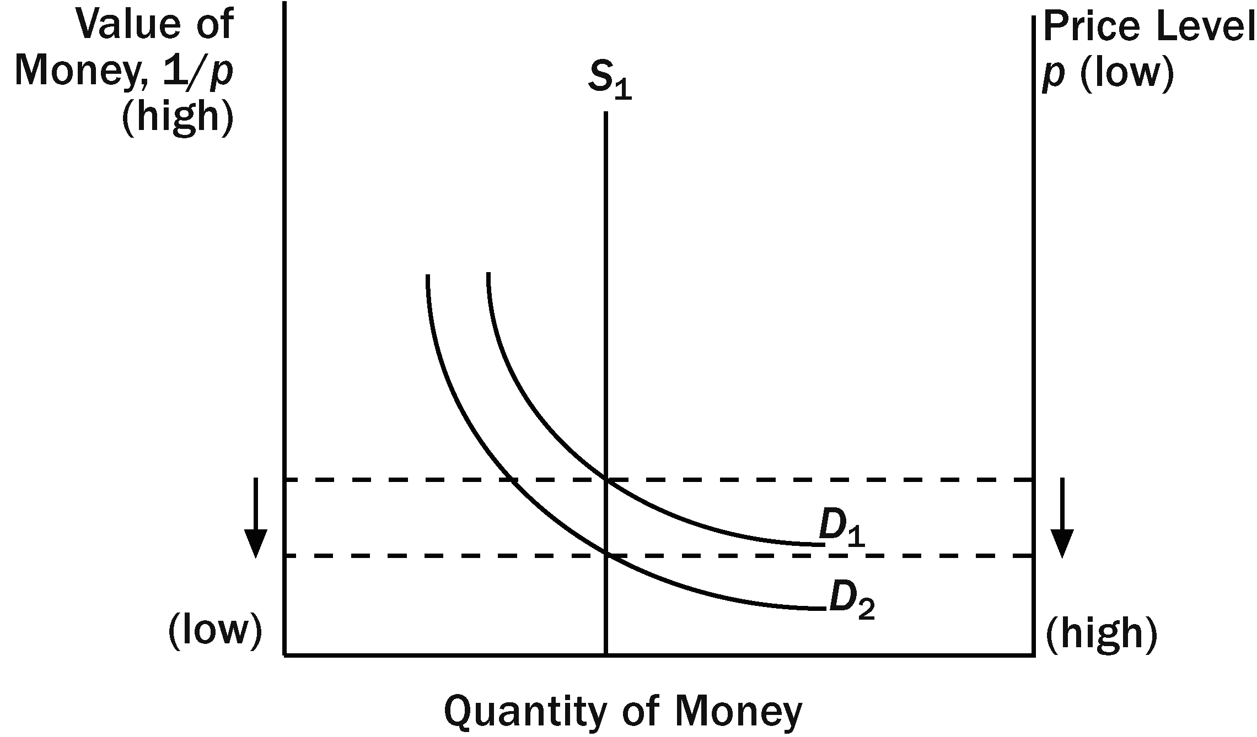

Figure 1

c. If the Fed wants to keep the price level stable, it should reduce the money supply from S₁ to S₂ in Figure 2. This would cause the supply of money to shift to the left by the same amount that the demand for money shifted, resulting in no change in the value of money and the price level.

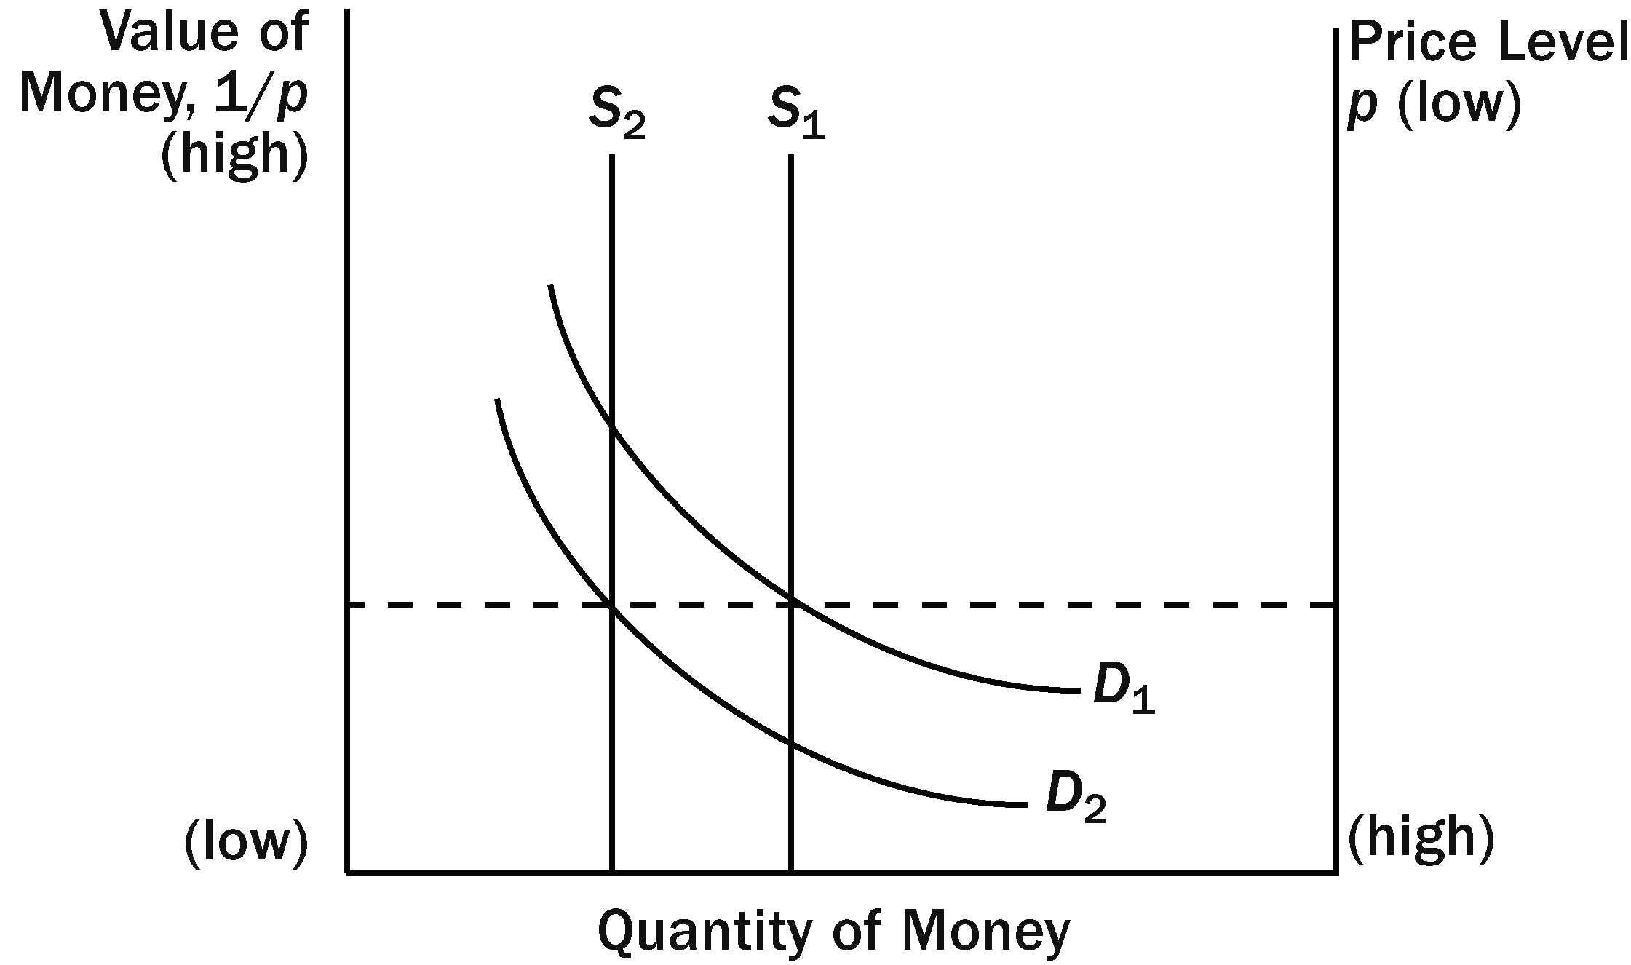

Figure 2

3. With constant velocity, reducing the inflation rate to zero would require the money growth rate to equal the growth rate of output, according to the quantity theory of money (M × V = P × Y ).

4. If a country's inflation rate increases sharply, the inflation tax on holders of money increases significantly. Wealth in savings accounts is not subject to a change in the inflation tax because the nominal interest rate will increase with the rise in inflation. But holders of savings accounts are hurt by the increase in the inflation rate because they are taxed on their nominal interest income, so their real returns are lower.

5. a. When the price of both goods doubles in a year, inflation is 100%. Let’s set the market basket equal to one unit of each good. The cost of the market basket is initially $4 and becomes $8 in the second year. Thus, the rate of inflation is ($8 – $4)/$4 × 100 = 100%. Because the prices of all goods rise by 100%, the farmers get a 100% increase in their incomes to go along with the 100% increase in prices, so neither is affected by the change in prices.

b. If the price of beans rises to $2 and the price of rice rises to $4, then the cost of the market basket in the second year is $6. This means that the inflation rate is ($6 – $4)/$4 × 100 = 50%. Bob is better off because his dollar revenues doubled (increased 100%) while inflation was only 50%. Rita is worse off because inflation was 50% percent, so the price of the good she buys rose faster than the price of the good (rice) she sells, which rose only 33%.

c. If the price of beans rises to $2 and the price of rice falls to $1.50, then the cost of the market basket in the second year is $3.50. This means that the inflation rate is ($3.5 – $4)/$4 × 100 = -12.5%. Bob is better off because his dollar revenues doubled (increased 100%) while prices overall fell 12.5%. Rita is worse off because inflation was -12.5%, so the price of the good she buys didn't fall as fast as the price of the good (rice) she sells, which fell 50%.

d. The relative price of rice and beans matters more to Bob and Rita than the overall inflation rate. If the price of the good that a person produces rises more than inflation, he will be better off. If the price of the good a person produces rises less than inflation, he will be worse off.

6. The following table shows the relevant calculations:

 | (a) | (b) | (c)
(1) Nominal interest rate | 10.0 | 6.0 | 4.0
(2) Inflation rate | 5.0 | 2.0 | 1.0
(3) Before-tax real interest rate | 5.0 | 4.0 | 3.0
(4) Reduction in nominal interest rate due to 40% tax | 4.0 | 2.4 | 1.6
(5) After-tax nominal interest rate | 6.0 | 3.6 | 2.4
(6) After-tax real interest rate | 1.0 | 1.6 | 1.4

Row (3) is row (1) minus row (2). Row (4) is 0.40 × row (1). Row (5) is (1 – .40) × row (1), which equals row (1) minus row (4). Row (6) is row (5) minus row (2). Note that even though part (a) has the highest before-tax real interest rate, it has the lowest after-tax real interest rate. Note also that the after-tax real interest rate is much lower than the before-tax real interest rate.

7. The functions of money are to serve as a medium of exchange, a unit of account, and a store of value. Inflation mainly affects the ability of money to serve as a store of value, because inflation erodes money's purchasing power, making it less attractive as a store of value. Money also is not as useful as a unit of account when there is inflation, because stores have to change prices more often and because people are confused and inconvenienced by the changes in the value of money. In some countries with hyperinflation, stores post prices in terms of a more stable currency, such as the U.S. dollar, even when the local currency is still used as the medium of exchange. Sometimes countries even stop using their local currency altogether and use a foreign currency as the medium of exchange as well.

8. a. Unexpectedly high inflation helps the government by providing higher tax revenue and reducing the real value of outstanding government debt.

b. Unexpectedly high inflation helps a homeowner with a fixed-rate mortgage because he pays a fixed nominal interest rate that was based on expected inflation, and thus pays a lower real interest rate than was expected.

c. Unexpectedly high inflation hurts a union worker in the second year of a labor contract because the contract probably based the worker's nominal wage on the expected inflation rate. As a result, the worker receives a lower-than-expected real wage.

d. Unexpectedly high inflation hurts a college that has invested some of its endowment in government bonds because the higher inflation rate means the college is receiving a lower real interest rate than it had planned. (This assumes that the college did not purchase indexed Treasury bonds.)

9. a. The statement that "Inflation hurts borrowers and helps lenders, because borrowers must pay a higher rate of interest," is false. Higher expected inflation means borrowers pay a higher nominal rate of interest, but it is the same real rate of interest, so borrowers are not worse off and lenders are not better off. Higher unexpected inflation, on the other hand, makes borrowers better off and lenders worse off.

b. The statement, "If prices change in a way that leaves the overall price level unchanged, then no one is made better or worse off," is false. Changes in relative prices can make some people better off and others worse off, even though the overall price level does not change. See problem 6 for an illustration of this.

c. The statement, "Inflation does not reduce the purchasing power of most workers," is true. Most workers' incomes keep up with inflation reasonably well.

